**Domain and Range Problems**



**1)** The graph shows the path of a golf ball.

What is the range of this function?

**F** 0 < *y* < 100

**G** 0 ≤ *y* ≤ 100

**H** 0 ≤ *x* ≤ 5

**J** 0 < *x* < 5

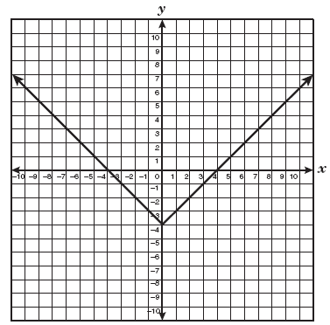**2)** Which of the following best represents the range of the function shown below?

**A** The range is all real numbers.

**B** The range is all real numbers greater than or equal to 4.

**C** The range is all real numbers greater than or equal to zero.

**D** The range is all real numbers greater than or equal to −4.

**3)** What is the domain of the function shown on the graph?



**A** −3 ≤ *x* ≤ 3

**B** −3 < *x* < 3

**C** −5 < *x* ≤ 4

**D** −5 ≤ *x* < 4

**4)** Which inequality best describes the range of the function

represented by this graph?



**A** *y* ≤ 3

**B** *y* ≤ 2

**C** *y* ≥ 3

**D** *y* ≥ 2

**5)** Which inequality best represents the domain of the function shown on the graph?



**F** −3 < *x* < 6

**G** −3 < *x* < 6

**H** −1 < *x* < 5

**J** −1 < *x* < 5

-

**6)** The graph of the function *y* =  is shown on the coordinate grid below.



What is the domain of the function?

**F** *x* < 5

**G** *x* > −5

**H** −5 < *x* < 5

**J** 0 < *x* < 5

**7)** Mr. Maxwell asked his students to identify the domain represented by the function graphed below.

Which of the following student responses is correct?



**F** −5 < *x* < 6

**G** −6 < *x* < 2

**H** −5 < *x* < −2

**J** Not here

**8)** Which of the following are the domain and range for the graph shown below?

**A** 0 ≤ *x* ≤ 4

0 ≤ *y* < 36

**B** 0 ≤ *x* ≤ 36

0.5 ≤ *y* ≤ 3.5

**C** 0.5 < *x* < 3.5

0 < *y* < 36

**D** 0.5 ≤ *x* ≤ 3.5

0 ≤ *y* ≤ 36

**9)** The graph of the function *y* = *x* + 3 is shown below on the coordinate grid.

What is the range of the function when

the domain is less than or equal to 2?



**A** The range is ≥ 2.

**B** The range is ≤ 5.

**C** The range is ≤ 3.

**D** The range is < 5.

**10)** A function is described by the equation *f* (*x*) = *x*2 + 5. The replacement set for the independent variable is {1, 5, 7, 12}. Which of the following is contained in the corresponding set for the dependent variable?

**A** 0

**B** 6

**C** 7

**D** 15

**11)** Which of the following mappings best represents the function *f*(*x*) = −*x*2 + 3?

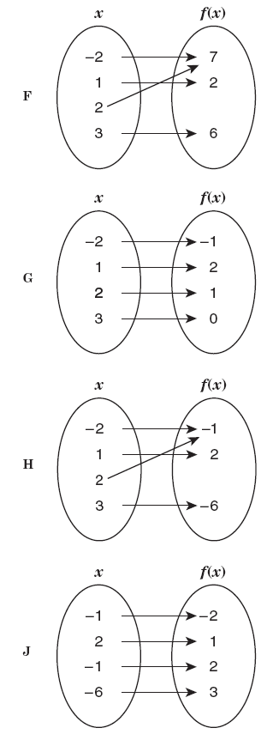**F G H J**

**12)** A function is described by the equation *y* = 2*x*2 − 5*x* − 3, in which *y* is dependent on *x*. If a value for the independent variable is selected from the set {−4, −1, 0, 2, 5}, which of the following is a corresponding dependent value?

**A** 9

**B** −6

**C** −5

**D** 0

|  |  |
| --- | --- |
| **13)** |  |
| **14)** |  |
| **15)** |  |
| **16)** |  |