DEFINITIONS:
DOMAIN: A list of every x-value in a table, graph, mapping, or set of ordered pairs.
RANGE: A list of every y-value in a table, graph, mapping, or set of ordered pairs.
Example 1: Example 2:
x

y

O

2

2

x | y
3 | -4
-1 | 7
-6 | -8
1 | 11
4 | 13

The DOMAIN is The DOMAIN is

The RANGE is The RANGE is

EXAMPLE 3: EXAMPLE 4:

3

-2

4

0

-1

-2

$\{ (-1, 9), (5, 9), (2.3, 7), (4, -2)\}$

The DOMAIN is The DOMAIN is
The RANGE is The RANGE is

Using inequalities we can show the domain and range of a graphed relation.

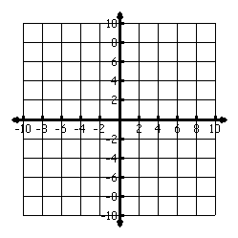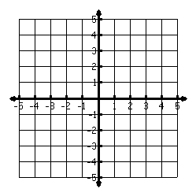Example 5: Example 6:

The DOMAIN is The DOMAIN is

The RANGE is The RANGE is

EXAMPLE 7: Is this a function? EXAMPLE 8:

The DOMAIN is The DOMAIN is

The RANGE is The RANGE is

WATCH OUT!!
- Remember that Domain and Range is a property/characteristic of a function. If a representation is not a function then you cannot list the domain and range.
- Do not list any number twice in the same list—unless it has different signs.

Practice 1: Practice 2:--WATCH OUT!!
x

y

O

2

2

x | y
5 | 2
-1 | 5.8
-2 | 6
1 | 18
8 | 0

The DOMAIN is x: The DOMAIN is

The RANGE is y: The RANGE is

Practice 3: Practice 4:--Watch Out!!

-17

-125

402

80

-16

-202

{(-2, 7), (-2, 5), (-2, -2), (2, 0)}

The DOMAIN is The DOMAIN is

The RANGE is The RANGE is

Practice 5: Practice 6:

The DOMAIN is The DOMAIN is

The RANGE is The RANGE is

Practice 7: Practice 8:

The DOMAIN is The DOMAIN is

The RANGE is The RANGE is

Domain and Range Homework

Find the range of each function when the domain is given.

1. $y = 3x + 2$ 2. $y = -5x + 1$ Domain = $\{ 1, 2, 3, 4\}$ Domain = $\{0, 2, 4, 6\}$

3. y = -4x – 2 4. y = 2x – 5 Domain = {-2, -1, 1, 2} Domain = {-1, 1, 3, 5}

5. y = 5x + 3 6. y = -½ x + 1
Domain = {1, 2, 3, 4} Domain = {3, 6, 9, 12}

7. y = ⅔x + 2 8. y = ¾x – 3
Domain = {2, 4, 6, 8} Domain = {0, 7,14,21}

9. y = ⅓x – 1 10. y = ¼x + 7
Domain={-10,-5,5,10} Domain = { -4, 0, 4, 8}

